**Report on Business Development Team Performance**

**Executive Summary:**

This report analyzes the performance of the Business Development Team based on a dataset comprising date, Three Associates (abc, xyz, klm) , leads generated, and time spent on lead generation activities.

**Detailed Analysis:**

**Data Cleaning:**

1.Loading and Exploration:

The datasets were loaded into Jupyter Notebook for analysis, Initial exploration revealed that the dataset contains three columns: Date, No. of Leads, and Time Spent on LG (in mins). The shape of the dataset is 196 rows and 3 columns.

Data Types:

* The 'Date' column is appropriately formatted as datetime
* 'Leads_Generated' and 'Time_Spent (in mins)' are numeric.

2.Handling Missing Values and Outliers:

Missing values and outliers were checked in the dataset. Calculate Z-Scores for numerical columns to find the Potential outliers and found three Outliers

|  |  |  |  |
| --- | --- | --- | --- |
| S.no | Date | No of Leads | Time Spent on LG (in mins) |
| 46 | 24/2/2023 | 1.0 | 60.0 |
| 53 | 3/3/2023 | 0.0 | 0.0 |
| 234 | 9/4/2023 | 23.0 | 200.0 |

**Data Exploration:**

Key Performance Indicators (KPIs) for each employee:

1. **Average Leads Generated per day**

* ASSOCIATE abc: 6.541666666666667, ASSOCIATE xyz: 10.95, ASSOCIATE klm: 9.688888888888888

1. **Average Time Spent per day**

* ASSOCIATE abc: 346.875, ASSOCIATE xyz: 387.0731707317073, ASSOCIATE klm: 384.766355140193

1. **Conversion Rate (Leads Generated per hour)**

* Associate abc: 1.1315315315315315, Associate xyz: 1.68241965973, Associate klm: 1.5360699538498

1. **Total Leads Generated over the given time period**

* Associate abc: 314.0, Associate xyz: 445.0, Associate klm: 1054.0

**Data Analysis and Visualization:**

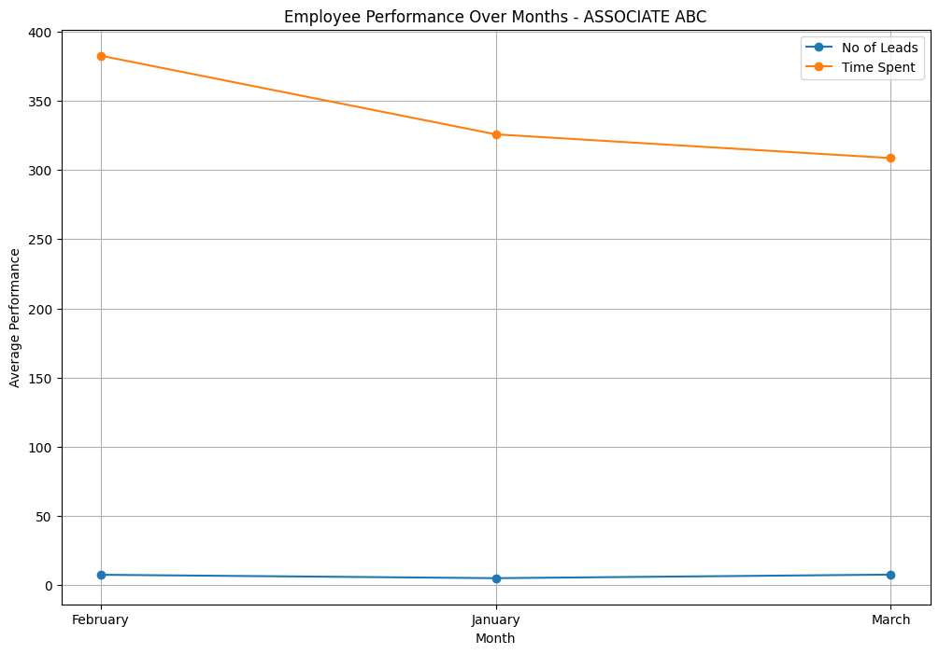Line charts were created to visualize the trend of employee performance over time.

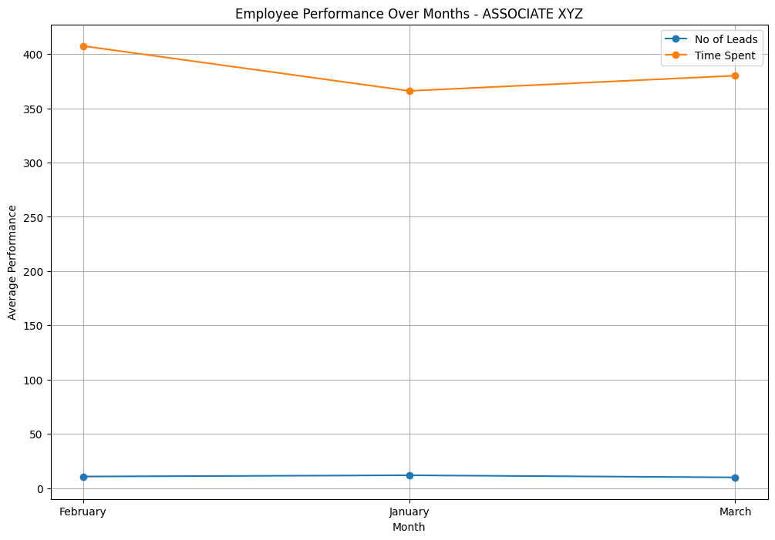

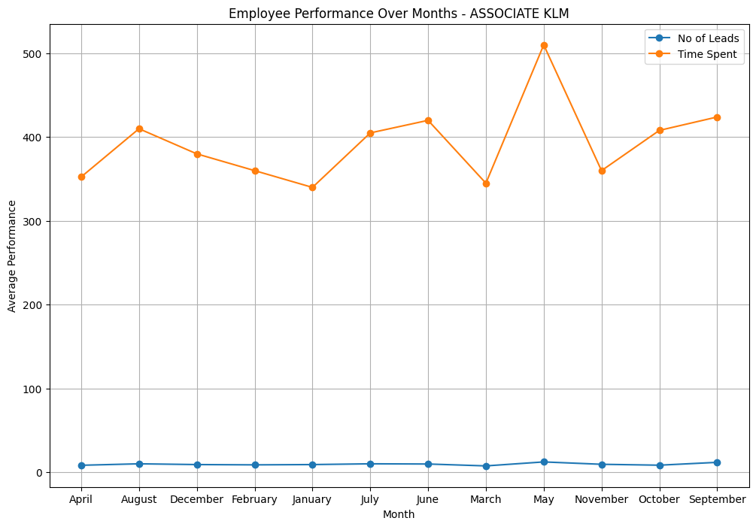

**Projections for Next Month:**

Tentative projections for the next month were made based on historical data. The expected leads generated and time spent for each employee are presented in the following chart/table

|  |  |  |
| --- | --- | --- |
| Prediction of Associate abc | | |
| s.no | No of Leads | Time Spent Projection |
| 0 | 1 | 219.785345 |
| 1 | 3 | 248.386195 |
| 2 | 6 | 291.287469 |
| 3 | 7 | 305.587894 |
| 4 | 9 | 334.188743 |
| 5 | 12 | 377.090018 |
| 6 | 13 | 391.390442 |
| 7 | 10 | 348.489168 |
| 8 | 2 | 234.085770 |
| 9 | 7 | 305.587894 |
| 10 | 5 | 276.987044 |
| 11 | 11 | 362.789593 |

|  |  |  |
| --- | --- | --- |
| Prediction for Associate xyz | | |
| S.NO | No of Leads | Time Spent Projection |
| 0 | 1 | 329.438006 |
| 1 | 3 | 353.385917 |
| 2 | 6 | 389.307785 |
| 3 | 7 | 401.281741 |
| 4 | 9 | 425.229652 |
| 5 | 12 | 461.151519 |
| 6 | 13 | 473.125475 |
| 7 | 10 | 437.203608 |
| 8 | 2 | 341.411962 |
| 9 | 7 | 401.281741 |
| 10 | 5 | 377.333829 |
| 11 | 11 | 449.177564 |

|  |  |  |
| --- | --- | --- |
| Prediction for Associate klm | | |
| S.no | No of Leads | Time Spent Projection |
| 0 | 1 | 289.079550 |
| 1 | 3 | 319.632784 |
| 2 | 6 | 365.462636 |
| 3 | 7 | 380.462636 |
| 4 | 9 | 411.292487 |
| 5 | 12 | 457.122338 |
| 6 | 13 | 472.398955 |
| 7 | 10 | 426.569104 |
| 8 | 2 | 304.356167 |
| 9 | 7 | 380.739253 |
| 10 | 5 | 350.186018 |
| 11 | 11 | 441.845721 |

**Answers to Questions:**

1. **Total Leads Generated by Each Associate:**

* Total leads by Associate ABC: 314.0, Associate XYZ: 445.0, Associate KLM: 1054.0

1. **Average Leads Generated by Each Associate:**

* Associate abc: 6.541666666666667, Associate xyz: 10.95, Associate klm: 9.688888888888888

1. **Most Consistent Associate in Lead Generation:**

* Associate xyz has most consistent associate in lead generation

1. **Handling Missing Values:**

missing values were replaced with value **zero** to fill the absent or undefined data, including NaN values in the dataset. Handling missing values is an important step in data cleaning and preprocessing, regardless of the specific representation used in the dataset.

**Recommendations:**

* Consider implementing a leave tracking system to better manage and plan team availability**.**
* Evaluate time spent on lead generation activities and provide time management training if necessary.
* Provide training on tools and platforms that can enhance efficiency and effectiveness in lead generation.

**Appendix:**

**Code and Tools:**

Language: Python

Libraries used: Numpy, pandas, matplotlib, seaborn, scikit-learn.

Tools: Jupyter notebook is used for analysis